Name:_________________________________ Period:_______

Road to War, the Civil War, and Reconstruction
Period 5
Chapters 13, 14, 15

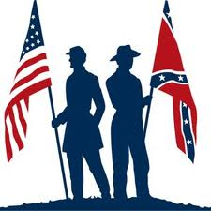

Manifest Destiny:___________________________________________________________________________________

_________________________________________________________________________________________________

Texas Revolution: ___________________________________________________________________________________

__________________________________________________________________________________________________

_________________________________________________________________________________________________

Lone Star Republic:__________________________________________________________________________________

The Alamo:________________________________________________________________________________________

Election of 1844:____________________________________________________________________________________

__________________________________________________________________________________________________

Internal Improvements:_______________________________________________________________________________

__________________________________________________________________________________________________

James K. Polk:_______________________________________________________________________________________

__________________________________________________________________________________________________

54, 40 or Fight:______________________________________________________________________________________

Pet Banks:__________________________________________________________________________________________

__________________________________________________________________________________________________

Annexation of Texas:_________________________________________________________________________________

__________________________________________________________________________________________________

_________________________________________________________________________________________________

Oregon Treaty:______________________________________________________________________________________

__________________________________________________________________________________________________

Joint Occupation:____________________________________________________________________________________

War With Mexico:__________________________________________________________________________________

__________________________________________________________________________________________________

Bear Flag Revolt:___________________________________________________________________________________

Wilmot Proviso:_____________________________________________________________________________________

_________________________________________________________________________________________________

Slave Power:________________________________________________________________________________________

__________________________________________________________________________________________________

Gag Rule:__________________________________________________________________________________________

Free Soil Party:______________________________________________________________________________________

Treaty of Guadalupe Hidalgo:__________________________________________________________________________

Oregon:___________________________________________________________________________________________

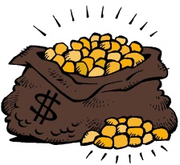
Mormon:________________________________________________________________________________________

_________________________________________________________________________________________________

Sante Fe:____________________________________________________________________________________

Gold Rush:_________________________________________________________________________________________

__________________________________________________________________________________________________

49ers:_____________________________________________________________________________________________

Mexican Cession:____________________________________________________________________________________

__________________________________________________________________________________________________

California:__________________________________________________________________________________________

__________________________________________________________________________________________________

Popular Sovereignty:_________________________________________________________________________________

Compromise of 1850:________________________________________________________________________________

__________________________________________________________________________________________________

__________________________________________________________________________________________________

Stephen Douglas:___________________________________________________________________________________

Fugitive Slave Act:___________________________________________________________________________________

_________________________________________________________________________________________________

Harriet Beecher Stowe:_______________________________________________________________________________

Uncle Tom’s Cabin:__________________________________________________________________________________

__________________________________________________________________________________________________

Ostend Manifesto:___________________________________________________________________________________

Railroad and Slavery:_________________________________________________________________________________

_________________________________________________________________________________________________

Gadsden Purchase:__________________________________________________________________________________

Franklin Pierce:______________________________________________________________________________________

_________________________________________________________________________________________________

1852 Election:______________________________________________________________________________________

__________________________________________________________________________________________________

Kansas-Nebraska Act:_________________________________________________________________________________

__________________________________________________________________________________________________

Border Ruffians:_____________________________________________________________________________________

Bleeding Kansas:____________________________________________________________________________________

__________________________________________________________________________________________________

John Brown:_____________________________________________________________________________________

__________________________________________________________________________________________________
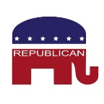
Republicans:________________________________________________________________________________________

__________________________________________________________________________________________________

American Party:_____________________________________________________________________________________

Know Nothings:_____________________________________________________________________________________

Nativism:__________________________________________________________________________________________

Violence in Congress:_________________________________________________________________________________

_________________________________________________________________________________________________

Election of 1856:____________________________________________________________________________________

James Buchanan:____________________________________________________________________________________

Dred Scott:_________________________________________________________________________________________

__________________________________________________________________________________________________

_________________________________________________________________________________________________

Roger Taney:_______________________________________________________________________________________

Freeport Doctrine:___________________________________________________________________________________

Harper’s Ferry:_____________________________________________________________________________________

_________________________________________________________________________________________________

Lincoln/Douglas Debate:_____________________________________________________________________________

_________________________________________________________________________________________________

Freeport Doctrine:___________________________________________________________________________________

Election of 1860:____________________________________________________________________________________

__________________________________________________________________________________________________

Abraham Lincoln:____________________________________________________________________________________

Secession:__________________________________________________________________________________________

Confederate States of America:_________________________________________________________________________

Jefferson Davis:_____________________________________________________________________________________

Crittenden Plan:_____________________________________________________________________________________

_________________________________________________________________________________________________

War Erupts:________________________________________________________________________________________

Border States:______________________________________________________________________________________

__________________________________________________________________________________________________

Inflation:__________________________________________________________________________________________

Draft Laws:_________________________________________________________________________________________

__________________________________________________________________________________________________

Class Tension:______________________________________________________________________________________

Draft Riots:________________________________________________________________________________________

War profiteering:___________________________________________________________________________________

National Bank Act:___________________________________________________________________________________

Greenbacks:________________________________________________________________________________________

Role of Women/War:________________________________________________________________________________

__________________________________________________________________________________________________

Baseball and the War:________________________________________________________________________________

__________________________________________________________________________________________________

Monitor v. Merrimac:________________________________________________________________________________

Radical Republicans:_________________________________________________________________________________

Fort Sumter:_______________________________________________________________________________________

Bull Run:__________________________________________________________________________________________

Stonewall Jackson:__________________________________________________________________________________

Generals:__________________________________________________________________________________________

Life on the Battlefield:________________________________________________________________________________

Emancipation Proclamation:__________________________________________________________________________

_________________________________________________________________________________________________
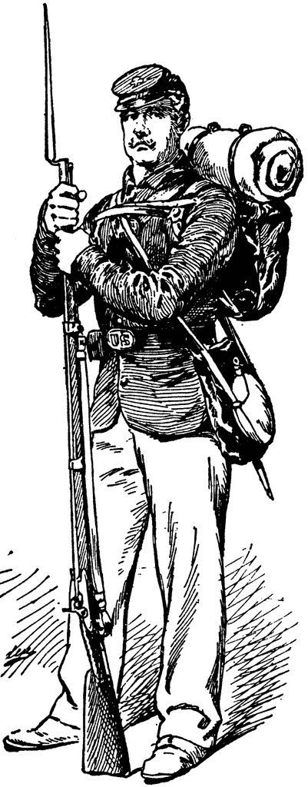
_________________________________________________________________________________________________

Confiscation Acts:__________________________________________________________________________________

_________________________________________________________________________________________________

Frederick Douglas:_________________________________________________________________________________

54th Massachusetts: ________________________________________________________________________________

_________________________________________________________________________________________________

Antietam:_________________________________________________________________________________________

_________________________________________________________________________________________________

Gettysburg:________________________________________________________________________________________

_________________________________________________________________________________________________

Atlanta:___________________________________________________________________________________________

Gettysburg Address:_________________________________________________________________________________

Prison Camps:______________________________________________________________________________________

_________________________________________________________________________________________________

Sherman’s March:___________________________________________________________________________________

__________________________________________________________________________________________________

Appomattox Courthouse:_____________________________________________________________________________

_________________________________________________________________________________________________

Lincoln Assassination:________________________________________________________________________________

__________________________________________________________________________________________________

_________________________________________________________________________________________________

13th Amendment:___________________________________________________________________________________

14th Amendment:___________________________________________________________________________________

_________________________________________________________________________________________________

15th Amendment:___________________________________________________________________________________

Hampton Roads Conference:__________________________________________________________________________

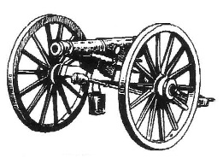
Copperheads:______________________________________________________________________________________

Reconstruction:_________________________________________________________________________________

_________________________________________________________________________________________________

Johnson’s Reconstruction:_____________________________________________________________________________

Swing Around the Circle:______________________________________________________________________________

Military Reconstruction Act:___________________________________________________________________________

Congressional Reconstruction:_________________________________________________________________________

__________________________________________________________________________________________________

Freedman’s Bureau:__________________________________________________________________________________

Ten Percent Plan:____________________________________________________________________________________

Wade-Davis Bill:_____________________________________________________________________________________

Loyalty Oath:_______________________________________________________________________________________

Pardoned:_________________________________________________________________________________________

Andrew Johnson:___________________________________________________________________________________

Black Codes:________________________________________________________________________________________

Special Field Order No. 15:____________________________________________________________________________

40 Acres and a Mule:_________________________________________________________________________________

__________________________________________________________________________________________________

Impeachment:______________________________________________________________________________________

__________________________________________________________________________________________________

_________________________________________________________________________________________________

Scalawags:_________________________________________________________________________________________

Carpetbaggers:_____________________________________________________________________________________

Gilded Age:________________________________________________________________________________________

Ulysses S. Grant:____________________________________________________________________________________

Grants Scandals:____________________________________________________________________________________

__________________________________________________________________________________________________

Credit Mobilier:_____________________________________________________________________________________

Whiskey Ring:_______________________________________________________________________________________

Panic of 1873:_______________________________________________________________________________________

__________________________________________________________________________________________________

Ku Klux Klan:______________________________________________________________________________________

_________________________________________________________________________________________________

_________________________________________________________________________________________________

Lynching:_________________________________________________________________________________________

White League:_____________________________________________________________________________________

Force Acts:_______________________________________________________________________________________

Slaughter House Cases:______________________________________________________________________________

Redeemers:_______________________________________________________________________________________

Boss Tweed:_______________________________________________________________________________________

Compromise of 1877:_______________________________________________________________________________

_________________________________________________________________________________________________

_________________________________________________________________________________________________

Southern African Americans:__________________________________________________________________________

_________________________________________________________________________________________________

Crop-lien System:___________________________________________________________________________________

Discrimination: ____________________________________________________________________________________

_________________________________________________________________________________________________

Jim Crow:_________________________________________________________________________________________

_________________________________________________________________________________________________

Grandfather Clause:_________________________________________________________________________________

_________________________________________________________________________________________________

NAACP:___________________________________________________________________________________________

WEB DuBois:_______________________________________________________________________________________

__________________________________________________________________________________________________

Booker T. Washingston:_______________________________________________________________________________

__________________________________________________________________________________________________

Great Migration:____________________________________________________________________________________

__________________________________________________________________________________________________

Plessy v. Ferguson:__________________________________________________________________________________

_________________________________________________________________________________________________

_________________________________________________________________________________________________

Separate but Equal: _________________________________________________________________________________

__________________________________________________________________________________________________

Election of 1876:__________________________________________________________________________________

________________________________________________________________________________________________

Rutherford Hayes:__________________________________________________________________________________

_________________________________________________________________________________________________

Compromise of 1877:_______________________________________________________________________________

_________________________________________________________________________________________________

Extra Space:
_________________________________________________________________________________________________

_________________________________________________________________________________________________

_________________________________________________________________________________________________

_________________________________________________________________________________________________

_________________________________________________________________________________________________

_________________________________________________________________________________________________

_________________________________________________________________________________________________

_________________________________________________________________________________________________

_________________________________________________________________________________________________

_________________________________________________________________________________________________

_________________________________________________________________________________________________

_________________________________________________________________________________________________

_________________________________________________________________________________________________

_________________________________________________________________________________________________

_________________________________________________________________________________________________

_________________________________________________________________________________________________

_________________________________________________________________________________________________

_________________________________________________________________________________________________

